COMP. 6108

Assignment 1 Part 2

George Czabania

27002246

15th October 2013

!

Table of Contents

Introduction 3

Logical Design 4

The Integrated Normalised Entity-Relationship Diagram 4

Physical Design 5

Relations 5

Data Volume Map 6

Data Usage Maps 7

All Students and Matching Vacancies 7

All Students Interested in One Vacancy 8

Considerations for De-normalisation 9

Partitioning 11

Advantages 11

Final Entity Relationship Diagram 12

Data Dictionary 13

Location 13

Employer 13

Vacancy 13

Student 14

Skill 14

StudentSkill 15

VacancySkill 15

Applicant 15

Appendix 16

Communications with client 16

Part 1 16

Part 2 16

# Introduction

In this report I will take the logical design and convert it into a physical design and implantation.

Modeling the data volume and access frequency.

This includes considering possible de-normalization methods.

And an SQL script file that will create the tables including the referential integrity rules as well as populating it with some test data into it.

# Logical Design

## The Integrated Normalised Entity-Relationship Diagram

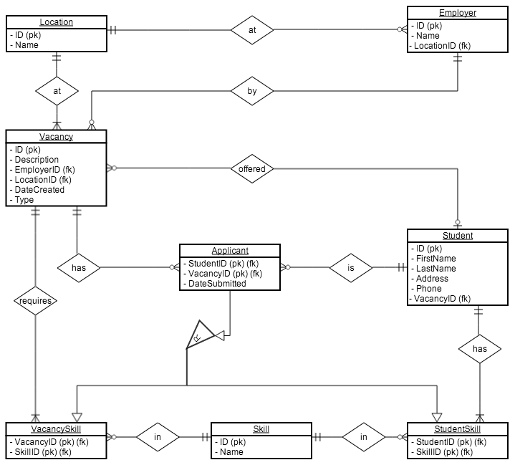

# Physical Design

## Relations

**Tables**

* Location(ID, Name)
* Vacancy(ID, Description, EmployerID, LocationID, DateCreated, Type)
* Employer(ID, Name, LocationID)
* VacancySkill(VacancyID, SkillID)
* Skill(ID, Name)
* StudentSkill(StudentID, SkillID)
* Student(ID, FirstName, LastName, Address, Phone)
* Applicant(StudentID, VacancyID, DateSubmitted)

**Foreign Keys**

* Vacancy
  + EmployerID: ON DELETE NO ACTION
  + LocationID: ON DELETE NO ACTION
* Employer
  + LocationID: ON DELETE NO ACTION
* VacancySkill
  + SkillID: ON DELETE CASCADE
  + VacancyID: ON DELETE CASCADE
* StudentSkill
  + SkillID: ON DELETE CASCADE
  + StudentID: ON DELETE CASCADE
* Applicant
  + StudentID: ON DELETE CASCADE
  + VacancyID: ON DELETE CASCADE

## Data Volume Map

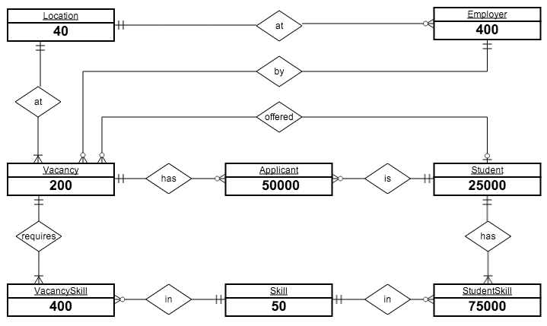

The estimated volumes were gathered from the client:

* Location: 40
* Employer: 400
* Vacancy: 200
* Student: 25000
* Skill: 50
* Applicant: (2 per Student) = 50000
* VacancySkill: (2 per Vacancy) = 400
* StudentSkill: (3 per Student) = 75000

## Data Usage Maps

### All Students and Matching Vacancies

This process is run 200 times a day.

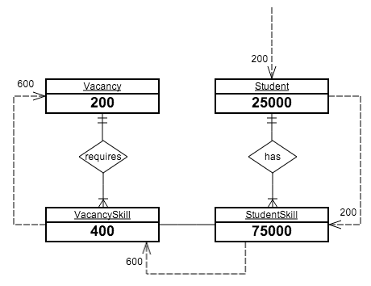

Assumptions:

* For each request for a Student, one request will need to be made to get a list of their Skills.
* On average, Students have three Skills. For each of these Skills, we will need to check it against every VacancySkill and match the SkillID attribute.
* For each VacancySkill we need to get the Vacancy, this takes a single request per VacancySkill.

### All Students Interested in One Vacancy

This process is run 150 times a day.

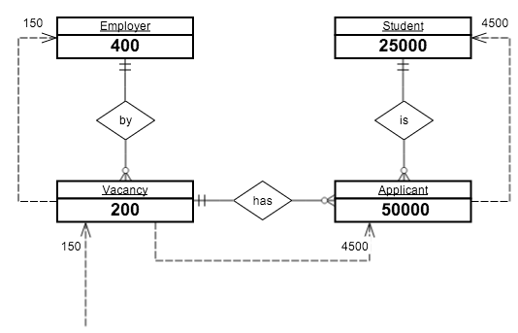

Assumptions:

* For each Vacancy we need to send one request to get the Employer.
* On average, a Vacancy will have 30 Applicants. For each of these Applicants, we need to send a request.
* For each Applicant we need to send one request to get the Student details of who applied.

## Considerations for De-normalisation

Based on:

* All Students and Matching Vacancies
* All Students Interested In One Particular Vacancy

**Disadvantages**

* Inconsistent speed access
* More complexity
* Extra space
* Slower update times

**Joining Tables to create a One-To-One relationship**

This de-normaliztion method is used to increase performance by reducing the number of joins the DBMS must do when querying information across multiple tables.

While not very useful in this system, and example scenario would be if the majority of employers only listed very few vacancies, and there were are large number of employers.

For example, we could merge vacancyskill and vacancy together. This would duplicate a lot of data, but would possibly improve performance.

**Vacancy**

|  |  |  |  |  |  |
| --- | --- | --- | --- | --- | --- |
| **s** | **Description** | **EmployerID** | **LocationID** | **DateCreated** | **Type** |
| 1 | Cashier | 2 | 3 | 2013-10-22 | 0 |

**Skill**

|  |  |
| --- | --- |
| **VacancyID** | **SkillID** |
| 1 | 10 |
| 1 | 20 |
| 1 | 30 |

**Vacancy + Skill**

|  |  |  |  |  |  |  |
| --- | --- | --- | --- | --- | --- | --- |
| **ID** | **Description** | **EmployerID** | **LocationID** | **DateCreated** | **Type** | **SkillID** |
| 1 | Cashier | 2 | 3 | 2013-10-22 | 0 | 10 |
| 1 | Cashier | 2 | 3 | 2013-10-22 | 0 | 20 |
| 1 | Cashier | 2 | 3 | 2013-10-22 | 0 | 30 |

As you can see each vacancy is duplicated for every skill it requires. This makes maintaining it a lot harder, as rows could easily get out of sync if only one instance of them is changed.

**Horizontal partitioning**

Fox example, there are thousands of students stored in the database, but only the most recently added are regularly accessed. To improve performance, the Student table could be horizontally partitioned into sections of a 1000 students.

Student_0_999, Student_1000_1999, Student_2000_2999

This particular type of portioning is known as “key range partitioning” because the primary key is used to create the groups.

This is faster, as the DBMS has fewer students to sort through per table.

However more logic is required for the system to know which table to open to find a student.

Not going to do this as the database should be handle 25000 students assuming that most of the students already have gained employment and will be excluded from the results.

**Vertical Partitioning**

Need to store more information, as the primary key is duplicated on each sub-table.

This involves splitting up tables by distributing the columns of a table into several separate tables.

This is not very useful for this database, as all the tables have a small amount of columns that is accessed at the same time.

An example would be if the Student tables was accessed very often to get each students first and last name. The student table also stores the phone number and address of each student, but this information is accessed rarely. To improve performance in this scenario, the student table could be vertically partitioned to create two tables:

**Student**

|  |  |  |  |  |
| --- | --- | --- | --- | --- |
| **StudentID** | **FirstName** | **LastName** | **Phone** | **Address** |
| 2 | George | Smith | 123 | 20 Round St |

|  |  |  |  |  |  |  |
| --- | --- | --- | --- | --- | --- | --- |
| **Student_Name** | | |  | **Student_Contact** | | |
| **StudentID** | **FirstName** | **LastName** |  | **StudentID** | **Phone** | **Address** |
| 2 | George | Smith |  | 2 | 123 | 20 Round St |

This improves performance for queries that only get the name of the student, or the phone and address. But slows down performance for queries that need both the name and phone or address.

Makes managing foreign keys harder, as you have to check referential integrity on both tables.

Not ideal use case, as phone and address data are not used in the two main processes. And moving them into a separate table doesn’t help us. It would if we accessed it separately to the name.

Also makes it harder to manage the database as the student information is split.

Not going to do this.

**Partitioning overall**

Add’s a lot of complexity into the database, with minimal speed gains for these two processes.

**Indexing**

Creating indexes for columns that are not primary keys.

We should index foreign keys, to make joining table faster.

However for both of the important processes, every attribute that is accessed is already a primary key and has a index.

Except for Vacancy.EmployerID.

We could index this field, but it wouldn’t help in either of the two processes, as we are querying the Vacancy table by the ID, which is already indexed.

### Partitioning

Splitting a table into multiple parts.

### Advantages

Advantages of using de-normalization.

* Harder to maintain
* Faster access times

## Final Entity Relationship Diagram



No changes were made to the original entity relationship diagram.s

## Data Dictionary

### Location

|  |  |  |  |  |  |  |  |  |  |
| --- | --- | --- | --- | --- | --- | --- | --- | --- | --- |
| **Name** | **Description** | **Data Type** | **Size** | **Example** | **Required** | **Indexed** | **Primary Key** | **Foreign Key** | **Default Value** |
| ID | Location ID | int | 8 | 12 | ✔ | ✔ | ✔ |  |  |
| Name | Location Name | varchar | 30 | Lynmore | ✔ |  |  |  |  |

### Employer

|  |  |  |  |  |  |  |  |  |  |
| --- | --- | --- | --- | --- | --- | --- | --- | --- | --- |
| **Name** | **Description** | **Data Type** | **Size** | **Example** | **Required** | **Indexed** | **Primary Key** | **Foreign Key** | **Default Value** |
| ID | Employer ID | int | 8 | 48 | ✔ | ✔ | ✔ |  |  |
| Name | Employer Name | varchar | 30 | Wairiki | ✔ |  |  |  |  |
| LocationID | Employer location | int | 8 | 2 | ✔ |  |  | ✔ |  |

### Vacancy

|  |  |  |  |  |  |  |  |  |  |
| --- | --- | --- | --- | --- | --- | --- | --- | --- | --- |
| **Name** | **Description** | **Data Type** | **Size** | **Example** | **Required** | **Indexed** | **Primary Key** | **Foreign Key** | **Default Value** |
| ID | Vacancy ID | int | 8 | 15 | ✔ | ✔ | ✔ |  |  |
| Description | Vacancy Description | varchar | 30 | Lynmore | ✔ |  |  |  |  |
| EmployerID | Vacancy Employer | int | 8 | 32 | ✔ |  |  | ✔ |  |
| LocationID | Vacancy Location | int | 8 |  | ✔ |  |  | ✔ |  |
| DateCreated | Date Vacancy was created | timestamp |  | 2013-10-22 18:45:00 | ✔ |  |  |  | CURRENT TIMESTAMP |
| Type | Full time or part time | int | 1 | 0 | ✔ |  |  |  |  |

### Student

|  |  |  |  |  |  |  |  |  |  |
| --- | --- | --- | --- | --- | --- | --- | --- | --- | --- |
| **Name** | **Description** | **Data Type** | **Size** | **Example** | **Required** | **Indexed** | **Primary Key** | **Foreign Key** | **Default Value** |
| ID | Student ID | int | 8 | 2732 | ✔ | ✔ | ✔ |  |  |
| FirstName | Student First Name | varchar | 30 | Jim | ✔ |  |  |  |  |
| LastName | Student Last Name | varchar | 30 | Smith | ✔ |  |  |  |  |
| Address | Student Address | varchar | 100 | 19 Devon St Rotorua | ✔ |  |  |  |  |
| Phone | Student Phone Number | varchar | 20 | 021 793 082 | ✔ |  |  |  |  |

### Skill

|  |  |  |  |  |  |  |  |  |  |
| --- | --- | --- | --- | --- | --- | --- | --- | --- | --- |
| **Name** | **Description** | **Data Type** | **Size** | **Example** | **Required** | **Indexed** | **Primary Key** | **Foreign Key** | **Default Value** |
| ID | Skill ID | int | 8 | 2 | ✔ | ✔ | ✔ |  |  |
| Name | Skill Description | varchar | 20 | Word Processing | ✔ |  |  |  |  |

### StudentSkill

|  |  |  |  |  |  |  |  |  |  |
| --- | --- | --- | --- | --- | --- | --- | --- | --- | --- |
| **Name** | **Description** | **Data Type** | **Size** | **Example** | **Required** | **Indexed** | **Primary Key** | **Foreign Key** | **Default Value** |
| SkillID | Student Skill | int | 8 | 12 | ✔ | ✔ | ✔ | ✔ |  |
| StudentID | Student ID | int | 8 | 23 | ✔ | ✔ | ✔ | ✔ |  |

### VacancySkill

|  |  |  |  |  |  |  |  |  |  |
| --- | --- | --- | --- | --- | --- | --- | --- | --- | --- |
| **Name** | **Description** | **Data Type** | **Size** | **Example** | **Required** | **Indexed** | **Primary Key** | **Foreign Key** | **Default Value** |
| SkillID | Vacancy Skill | int | 8 | 52 | ✔ | ✔ | ✔ | ✔ |  |
| StudentID | Vacancy ID | int | 8 | 123 | ✔ | ✔ | ✔ | ✔ |  |

### Applicant

|  |  |  |  |  |  |  |  |  |  |
| --- | --- | --- | --- | --- | --- | --- | --- | --- | --- |
| **Name** | **Description** | **Data Type** | **Size** | **Example** | **Required** | **Indexed** | **Primary Key** | **Foreign Key** | **Default Value** |
| StudentID | Student ID | int | 4 | 12 | ✔ | ✔ | ✔ | ✔ |  |
| VacancyID | Vacancy ID | int | 8 | 32 | ✔ | ✔ | ✔ | ✔ |  |
| DateCreated | Date Application Created | timestamp |  | 2013-10-22 19:42:20 | ✔ |  |  |  | CURRENT TIMESTAMP |

# Appendix

## Communications with client

### Part 1

1. How many entries do you expect to store in each of these tables?

* Locations: **40**
* Employers: **400**
* Students: **25000**
* Skills: **50**
* Applicants (for students who have applied for a vacancy): **Applicants are students (on average 2 applications per student)**
* Student Skills (for skills that students have): **On average a student has 3 skills. You may calculate this.**
* Vacancy Skills (for skills required by vacancy): **On average a vacancy requires 2 skills. You may calculate this.**

1. How often will each of these tables be accessed (per hour)?

* **Limit this to the specified processes (two). The frequency of usage of such processes is mentioned in the assignment.**

### Part 2

1. How many entries do you expect to store in each of these tables?

* Vacancies: **200**

1. On average, how many applicants are there for each vacancy?

* **30 applicants for one vacancy.**